**Lab Report**

Title: Lab 3

Notice: Dr. Bryan Runck

Author: Zhaoxu Sui

Date: 12/1/2021

**Project Repository: https://github.com/KennethSui/GIS5571/tree/main/lab3**

**Google Drive Link:** **https://drive.google.com/drive/folders/1ZZEpn-FVDsQ9uIDry_Uo6p3tjueFW7uK?usp=sharing**

**Time Spent:** 10 hours

**Abstract**

In this project, I created an ETL for data to go into a cost surface model under an imaginary scenario. Firstly, I download the Land Cover data and elevation data to create a cost surface model. Then, I used the optimal regional connection tool to map the range of cost surfaces given uncertain preferences and model weights. However, the difference between lab 2 part 2 and lab 3 is that there is a hard constraint of water bodies.

**Problem Statement**

My objective is to use map algebra and cost modeling to create a cost surface for walking for an imaginary person named Dory, and then understand how uncertainty in model weights impacts that cost surface. Dory have several preferences and places that avoid to bypass, like farms, steep surfaces, and of course, water bodies.

*Sheet 1: Required Datasets for this lab task*

|  |  |  |  |  |  |  |
| --- | --- | --- | --- | --- | --- | --- |
| **#** | **Requirement** | **Defined As** | **(Spatial) Data** | **Attribute Data** | **Dataset** | **Preparation** |
| 1 | State Park Boundaries or Locations | A database which could represent the Whitewater State Park’s location. | Shapefile |  | MN Geospatial Commons | Derived from Notebook |
| 2 | Land Use Classification | A land cover dataset which could at least represent farm fields and water bodies. | Raster file,  TIFF might be the best |  | MN Geospatial Commons | Derived from Notebook |
| 3 | Elevation Data | A DEM dataset which helps identify the relief of Southeast Minnesota | Raster file,  TIFF might be the best |  | MN Geospatial Commons | Derived from Notebook |
| 4 | Road Data | A road dataset which shows the regional road networks in Minnesota. | Shapefile |  | MN Geospatial Commons | Derived from Notebook |

**Input Data**

*Sheet 2: Input datasets*

|  |  |  |  |
| --- | --- | --- | --- |
| **#** | **Title** | **Purpose in Analysis** | **Link to Source** |
| 1 | Minnesota Land Cover Classification and Impervious Surface Area by Landsat and Lidar: 2013 update - Version 2 | To re-weight each kinds of the land use classification to better exclude that Dory avoid to bypass. | [Mn GeoSpatial Commons](https://gisdata.mn.gov/dataset/base-landcover-minnesota) |
| 2 | State Parks, Recreation Areas, and Waysides | To identify the desired destination of Dory | [Mn GeoSpatial Commons](https://gisdata.mn.gov/dataset/bdry-dnr-lrs-prk) |
| 3 | Lidar Elevation, Southeast Minnesota, 2008 | To find the most gradual slopes of Dory | [Mn GeoSpatial Commons](https://gisdata.mn.gov/dataset/elev-lidar-semn2008) |
| 4 | Minnesota Road Networks, 2012 | To find bridges to help Dory successfully surpass waters | [Mn GeoSpatial Commons](https://gisdata.mn.gov/dataset/trans-roads-mndot-tis) |

**Methods**

Figure 1 Please enlarge it to see details

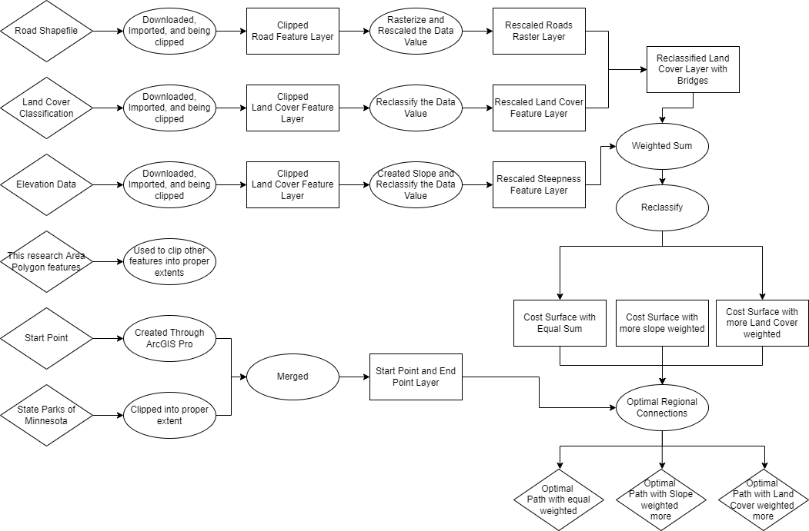

The whole process is programmed in the ArcGIS Pro notebook with the utilization of Arcpy functions as well as trivial manual manipulations in the ArcGIS Pro.

Firstly, I download the land cover dataset, Road Dataset, and the Elevation Dataset from MN DNR. I clipped them into proper extent and rescaled them. For the Land Cover Dataset, I gave water bodies and wetlands very low value like 1-3, and farmlands high values 101, and gave artificial surfaces and forests lower values around 110. For the elevation data, I transformed it into a slope graph, and rescaled it automatically, with the steeper area given lower value, and smoother area given higher value. For the Road data, I gave the places with roads a 100 value, and the places without roads with a 0 value.

Secondly, I downloaded the state parks dataset to find the Whitewater state park. Merged the point of the park and with the start point that derived from x y table. Thus, we have a point layer contains the start point and the end point.

Thirdly, I summed the land cover, and the road raster layers together, so there are mainly three ranges of data, ~0 mains water bodies, 100-110 mains farmlands or bridges on the water bodies, and ~200 mains roads. I reclassified and reversed it, so the water bodies can be a really hard constraints of around 1000 assigned by its value. I used the weighted sum function to merge the rescaled Land Use & Bridge layer and the Slope layer together and did this operation three times.

The first time I put the Land Cover/Bridges and the Slope into an equal weighted option with assigned both values 1.

The Second time I weighted Slope more with value of 3, but land cover/bridges remain the 1.

The Third time I weighted Slope more with value of 10, but land cover/bridges remain the 1.

Figure 2 Equal Weight Option, which shows the green areas as suitable for bypassing while red areas not suitable for walking by.

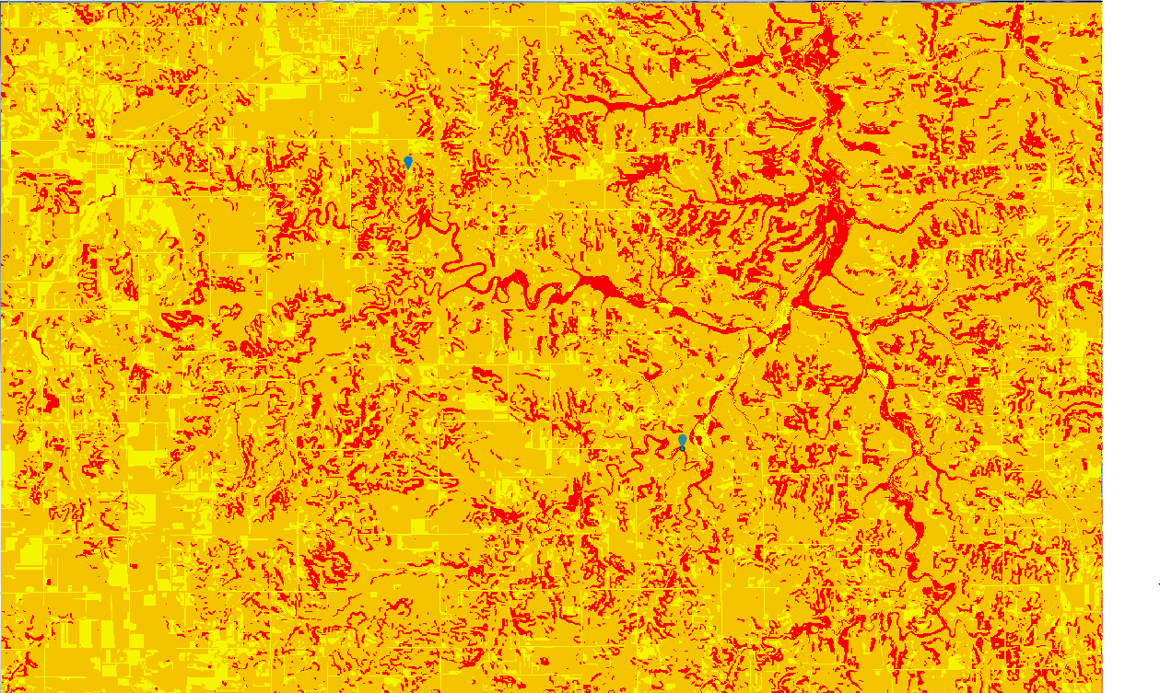

Figure 3 Slope Weighted More than the Land Cover

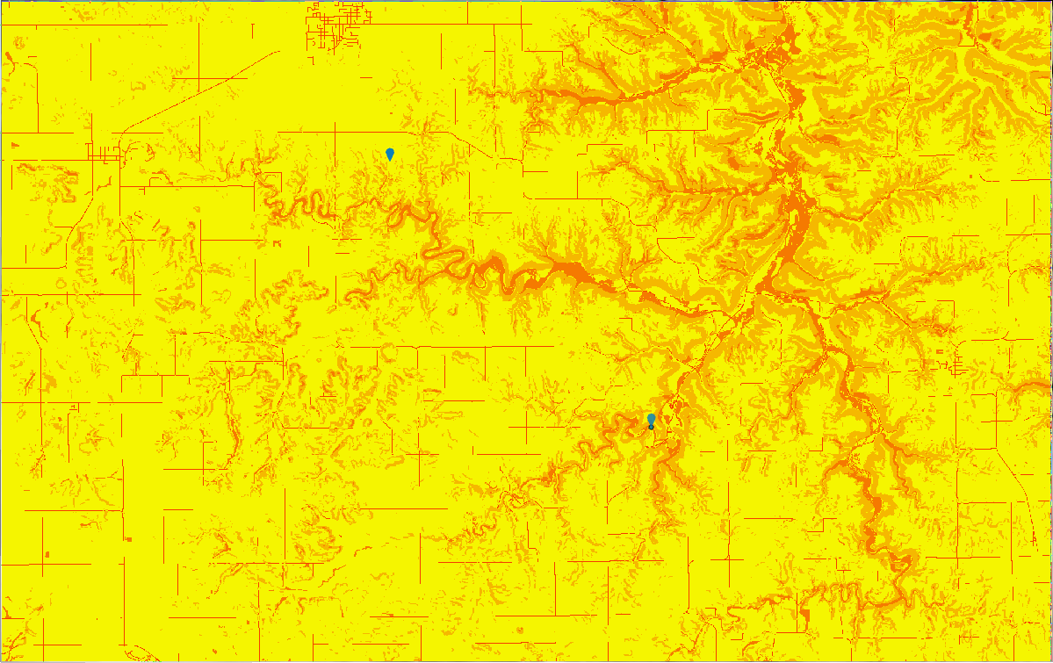

Figure 4 Slope Weighted Significantly more than the Land Covers

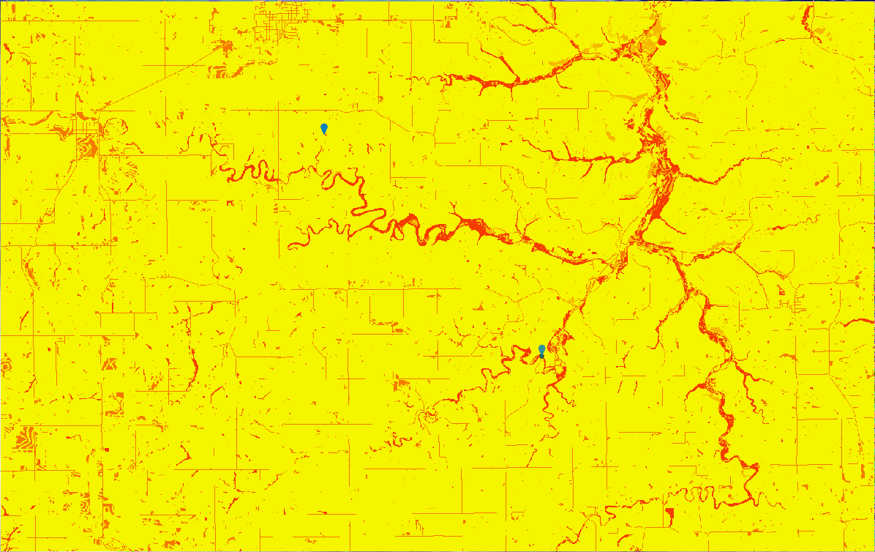

After the weighted sum operations, I used the optimal regional connections tool to calculate three different routes of choice under the scenario of different weighted cost surfaces. You can directly see the graph below.

**Results**

After the computation, I found all three results seems different from each other, but all these results have avoided significant water bodies, except the first one using bridges on the river.

Figure 5 Optimal Paths of all three options.

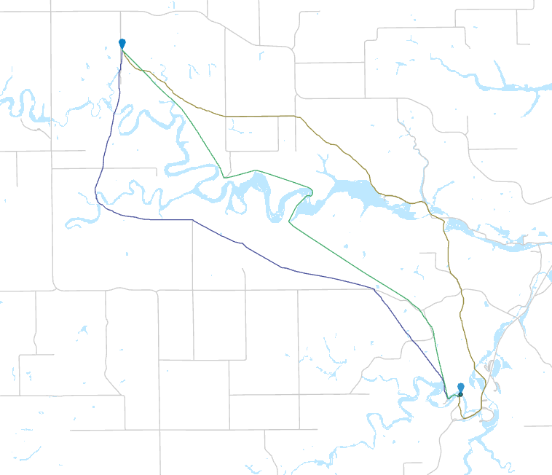

**Results Verification**

All the data are through carefully examined and verified. Except the result codes in the Jupyter notebooks, the pictures above also shows that the approach of making these results make sense. However, one pixel of water bodies is still being trespassed by Green Line (Optimal path 2), which I will expand it in the next section.

Figure 6 How three paths surpassed water bodies, grey mains roads

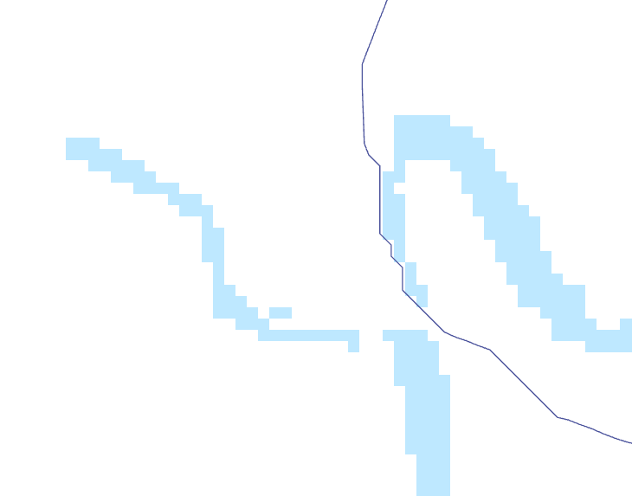 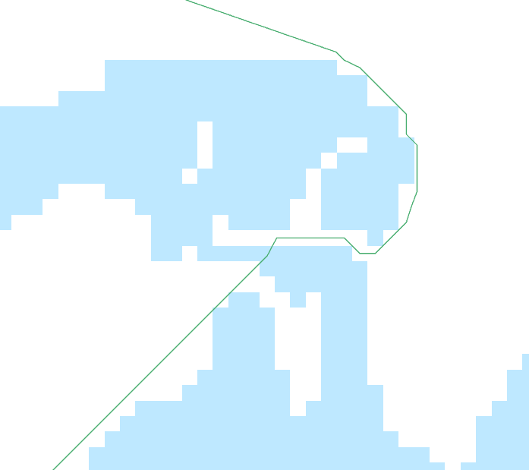 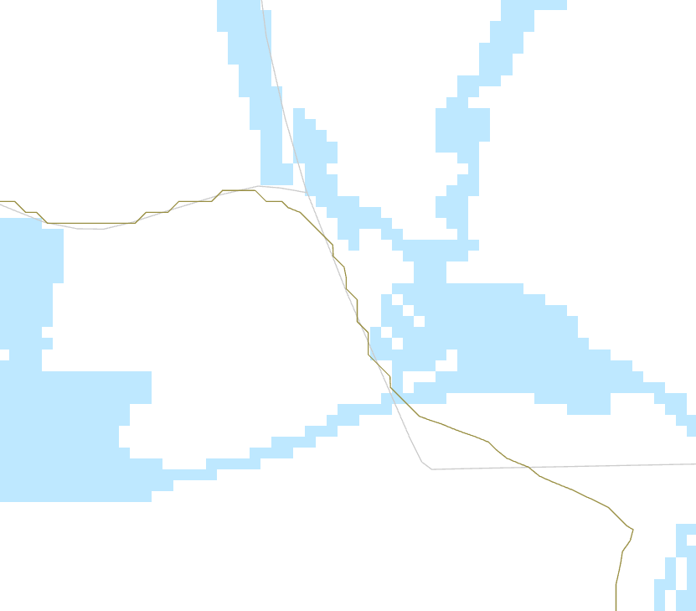

**Discussion and Conclusion**

In this exercise, I found it is really difficult to make a optimization that help Dory avoid water bodies at all. I noticed the barrier vectors that could be taken into considerations in the optimal regional connections, but I don’t know how I can cut off the rivers by roads to make the bridges notable in vector data. Thus, I tried to simulate the bridges by using raster datasets. All the water bodies without bridges are being assigned at a value of 1000, compared to other 1-10 values, but even 1000 is not enough.

As you can see in the verification above, the green line (Optimization Line 3) surpassed the water bodies by one pixel, without grey roads/bridges, which is theoretically not tolerable in this assignment still.

I would also like to see whether turning the values into 10000, 100000. Or I million might make the water bodies too costly that should be avoided in any scenarios. I would like to research more on the rescaling methods.

**References**

Creating a surface raster, Esri. Last Retrieved in 2021. https://pro.arcgis.com/en/pro-app/latest/tool-reference/spatial-analyst/creating-a-cost-surface-raster.htm

**Self-score**

*Fill out this rubric for yourself and include it in your lab report. The same rubric will be used to generate a grade in proportion to the points assigned in the syllabus to the assignment.*

|  |  |  |  |
| --- | --- | --- | --- |
| **Category** | **Description** | **Points Possible** | **Score** |
| **Structural Elements** | All elements of a lab report are included **(2 points each)**:  Title, Notice: Dr. Bryan Runck, Author, Project Repository, Date, Abstract, Problem Statement, Input Data w/ tables, Methods w/ Data, Flow Diagrams, Results, Results Verification, Discussion and Conclusion, References in common format, Self-score | 28 | **26** |
| **Clarity of Content** | Each element above is executed at a professional level so that someone can understand the goal, data, methods, results, and their validity and implications in a 5 minute reading at a cursory-level, and in a 30 minute meeting at a deep level **(12 points)**. There is a clear connection from data to results to discussion and conclusion **(12 points)**. | 24 | **22** |
| **Reproducibility** | Results are completely reproducible by someone with basic GIS training. There is no ambiguity in data flow or rationale for data operations. Every step is documented and justified. | 28 | **27** |
| **Verification** | Results are correct in that they have been verified in comparison to some standard. The standard is clearly stated **(10 points)**, the method of comparison is clearly stated **(5 points)**, and the result of verification is clearly stated **(5 points)**. | 20 | **18** |
|  |  | 100 | **95** |